

Mehran University of Engineering &
Technology Jamshoro, Pakistan

Complex Engineering Problem Report on Travely App

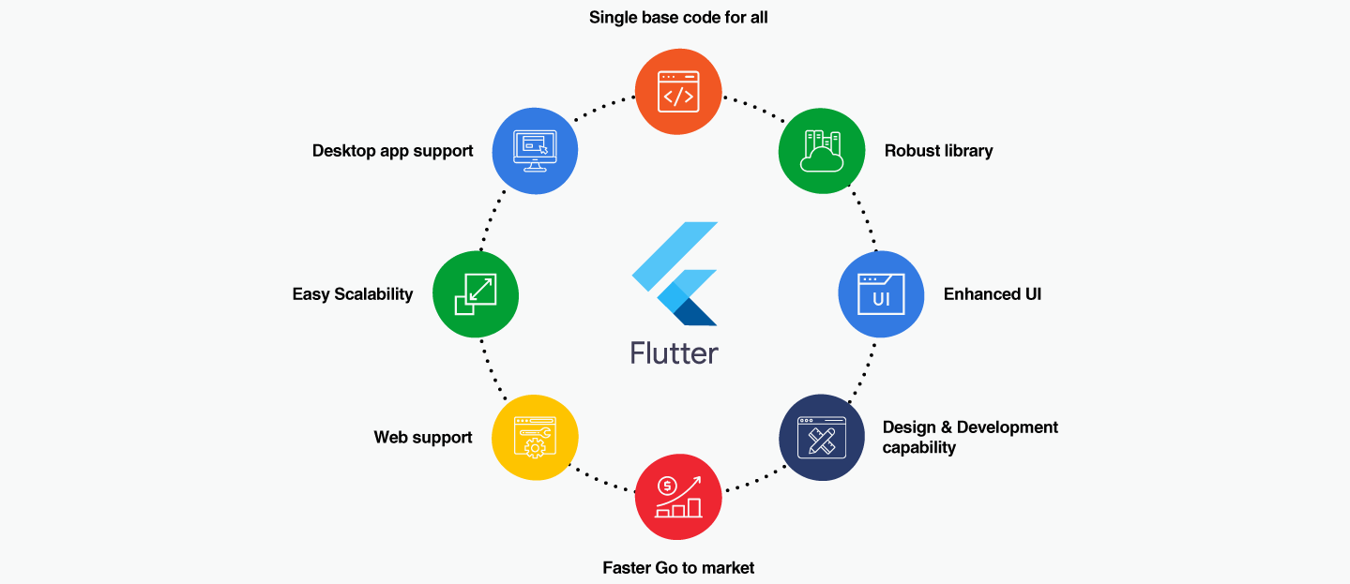

Roll No | 22SW028, 22SW040
Section | 01
Subject | MAD
CEP Project | Travely
Teacher | Sir Umar Farooque

1. Real-World Problem Identification
Tourists and travelers often struggle to find reliable information about notable attractions within a city, especially when traveling to unfamiliar regions. Existing travel apps are either too complex, lack local coverage, or display irrelevant global data.
Furthermore, travelers in developing regions face challenges like:
- Inconsistent internet access or poor data availability.
- Scattered information across multiple sources (Wikipedia, blogs, etc.).
- No centralized, user-friendly interface tailored to quick discovery.
This problem affects casual travelers, students, and professionals alike, who need a quick, lightweight, and visually appealing solution to explore nearby attractions without manual searching or unreliable sources.

2. Proposed Solution
To address this, we developed Travely:Your Simple Travel Mate, a cross-platform mobile application that helps users:
- Discover notable tourist attractions, landmarks, and monuments of any city.
- Search globally by city name (e.g., “Paris”, “Lahore”, “Tokyo”).
- View summarized Wikipedia data with images from Unsplash API.
- Save favorite places to the cloud using Firebase Firestore.
- Access a clean, responsive interface consistent across devices.

Key Features
- Smart City Search: Retrieves real, verified attractions from Wikipedia API and Unsplash.
- Dynamic UI: Auto-adapts to screen sizes, orientations, and themes.
- Favorites System: Syncs user favorites via Firebase authentication.
- Offline Resilience: Data persists locally when network drops.
- Cross-Platform Consistency: Built in Flutter; works seamlessly on Android & iOS.

System Architecture
- Frontend: Flutter (Material 3) with Provider for state management.
- Backend: Firebase Authentication + Firestore Database.
- APIs: Wikipedia REST API and Unsplash API.
- Hosting: Firebase and GitHub for version control.

3. Responsive User Interfaces
Travely’s UI was designed for simplicity and modernity using Flutter’s Material Design principles.
--> See the SS below:

Icon of my Tavely App



See my App

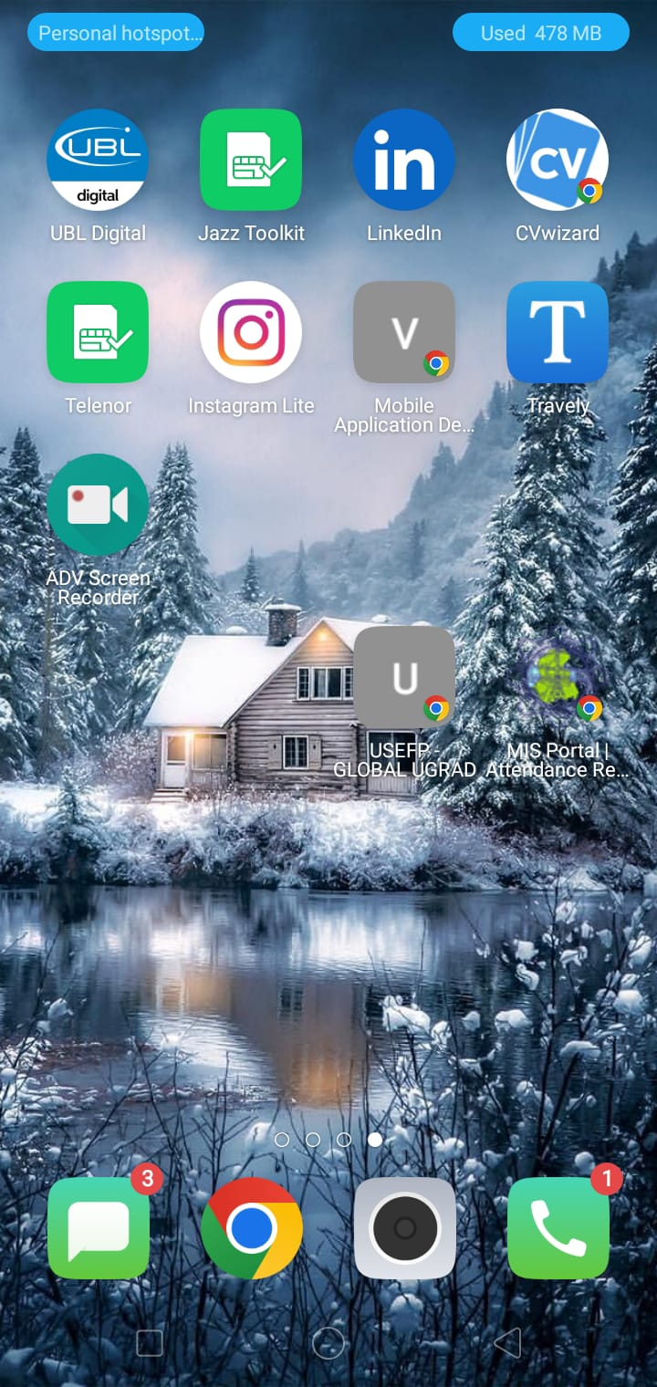

First see the app in mobile

The Splash Screen(Travely Branding)

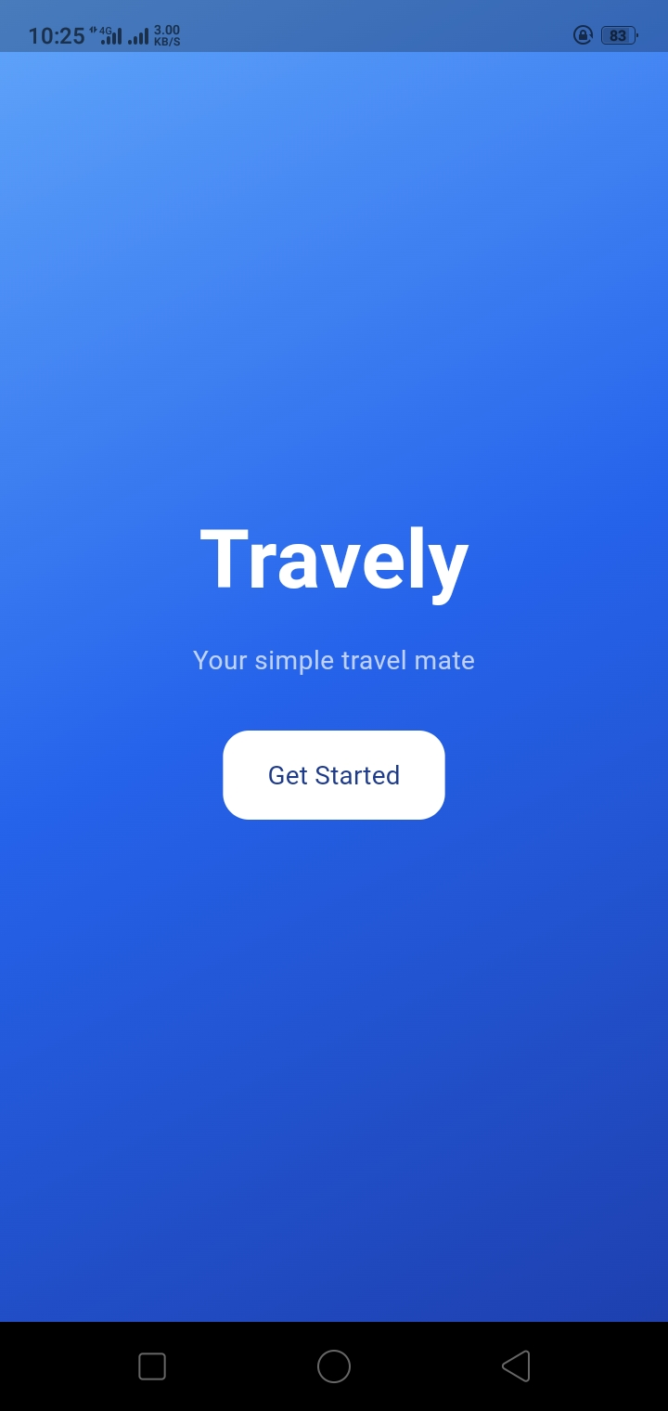

The Sign Up Screen(with email and Password)

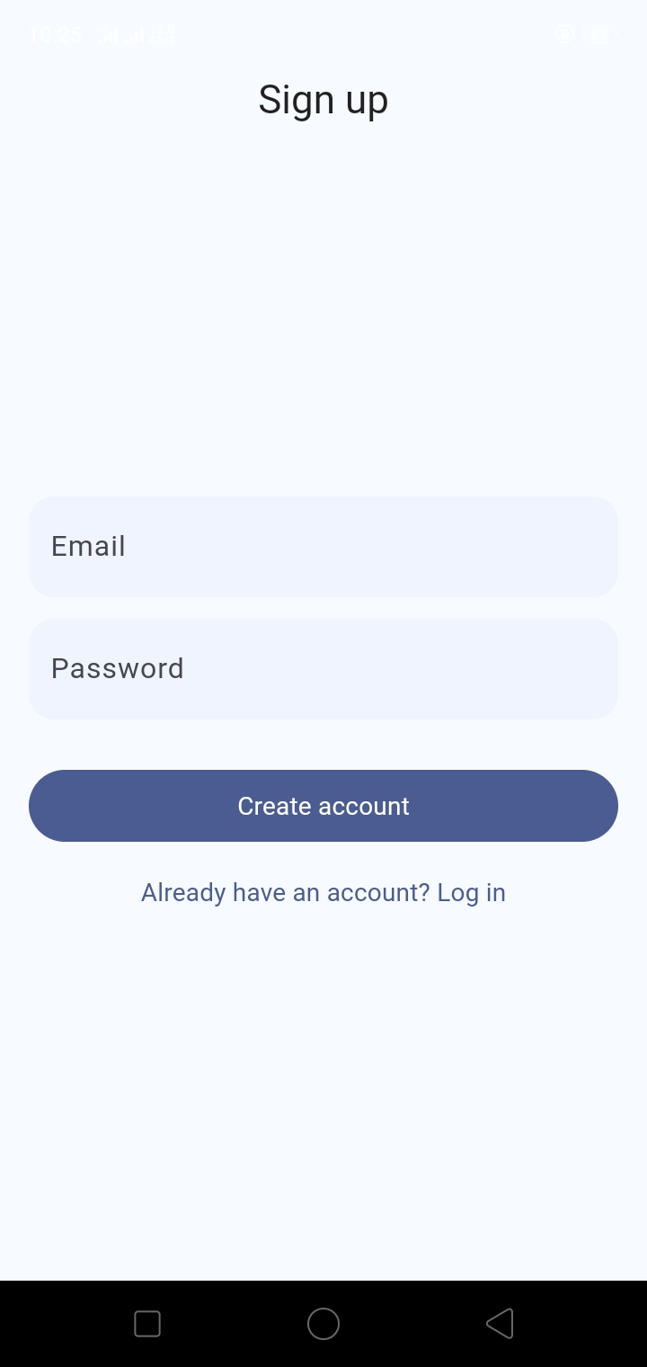

The Log in Screen

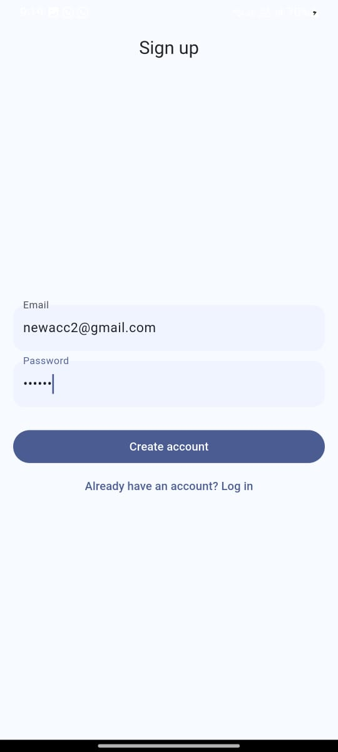

Our primary/main screen
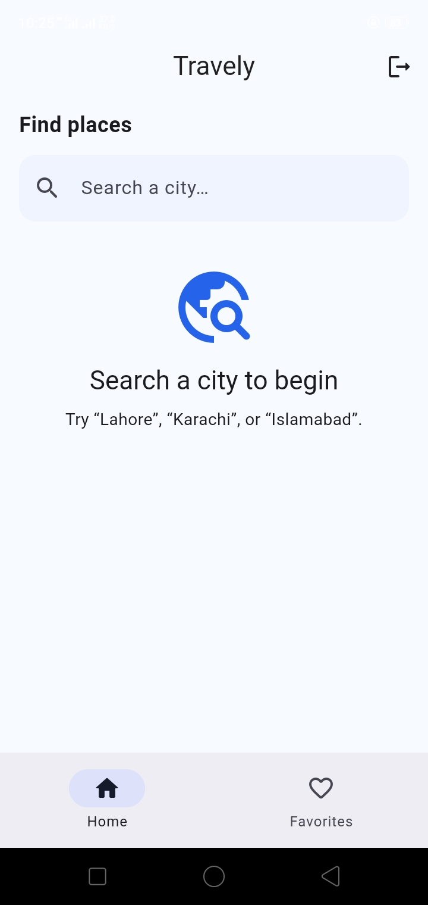

Now Searching for City in China (Harbin)
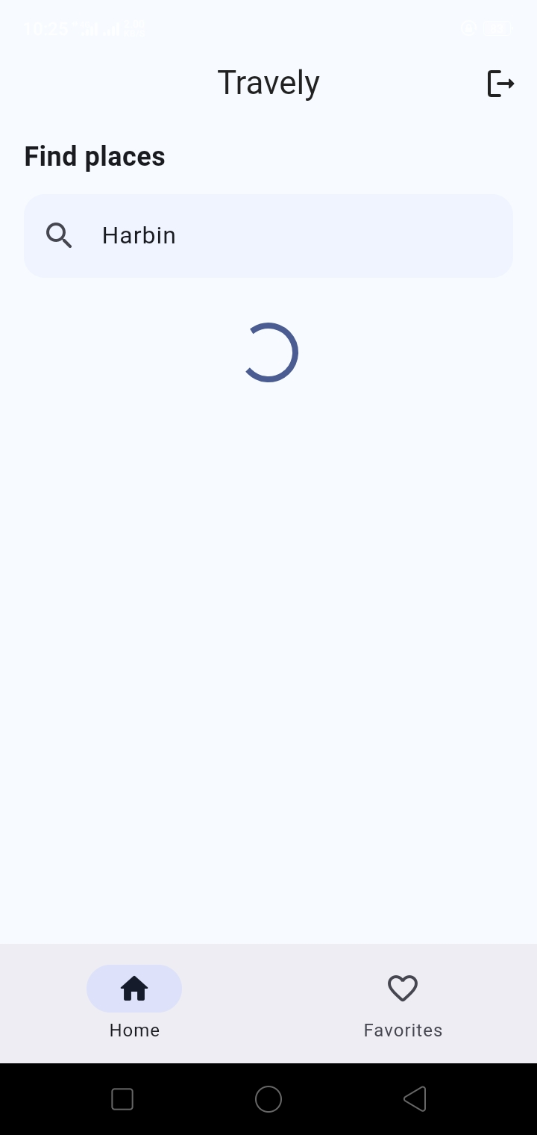

Our App is Fetching the travel places in (Harbin)

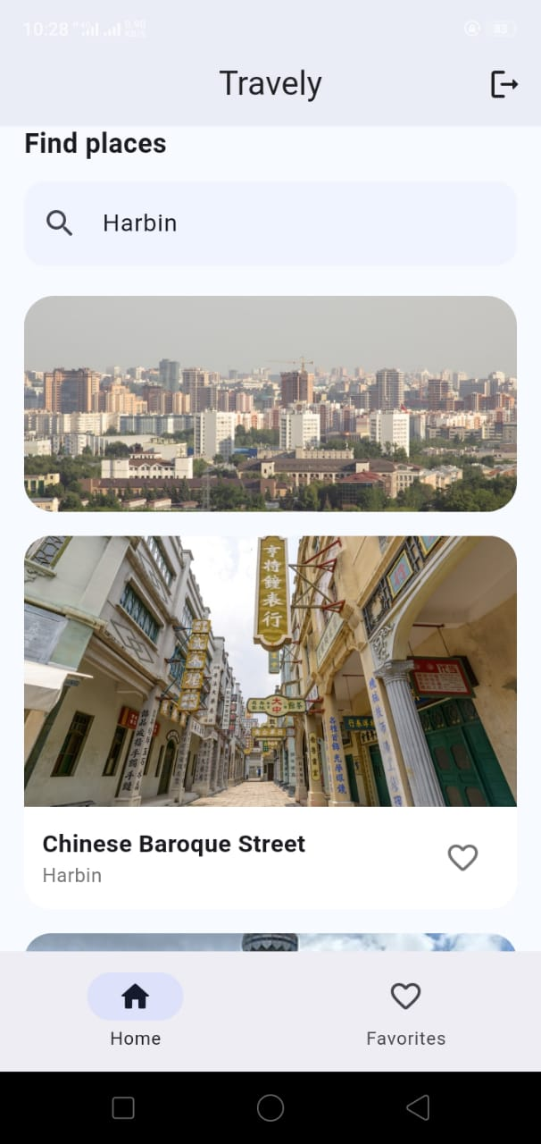

Adding Some Places to my Favorites

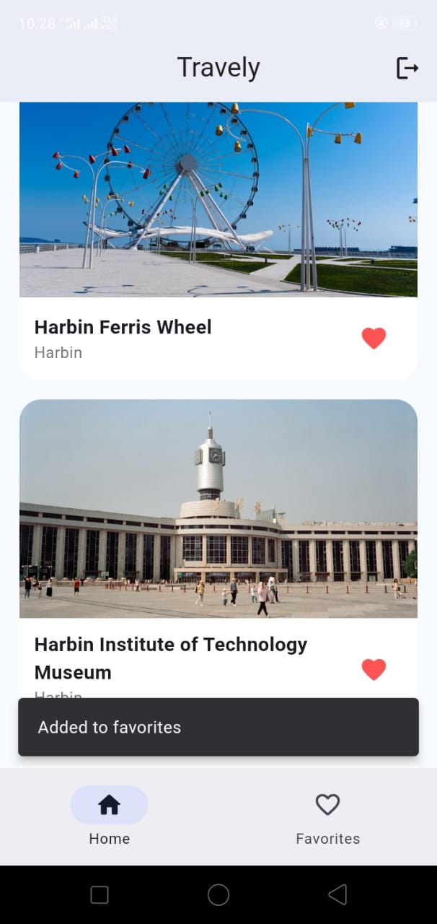

Now Opening one of the places by taping the Card (To see more Info about that Travel Place)

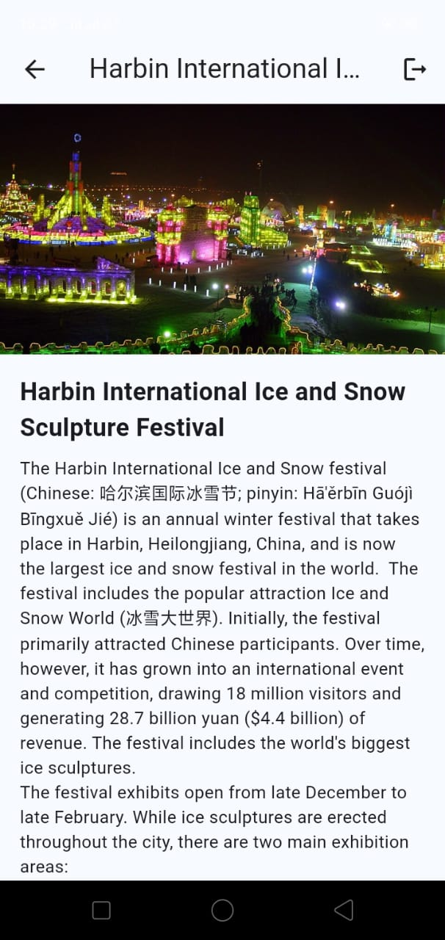

Also adding this one in my Fav places

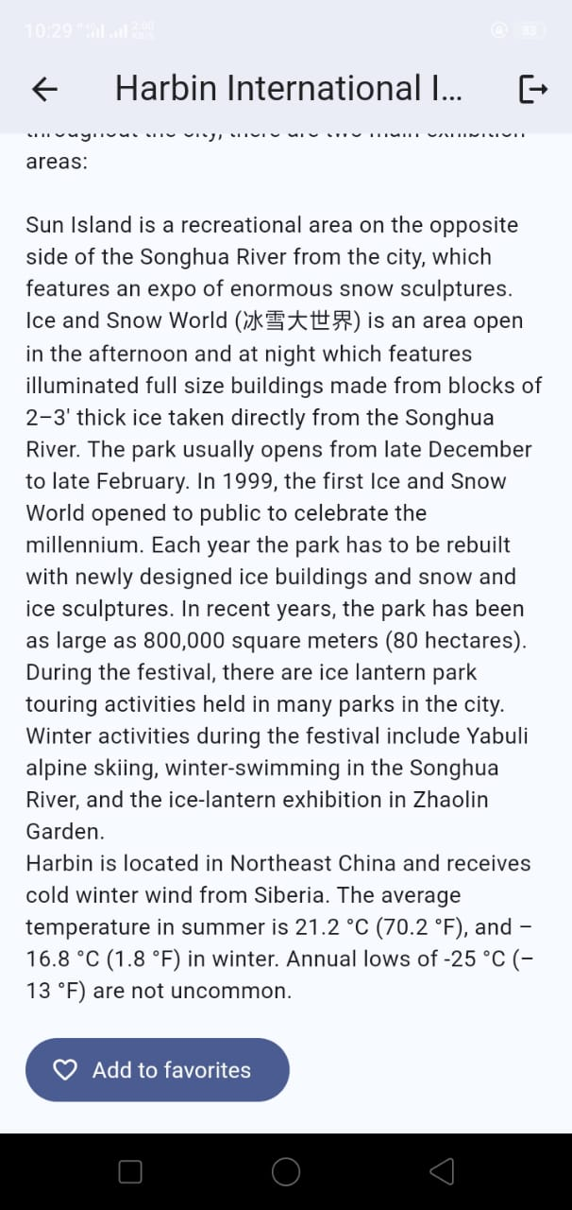

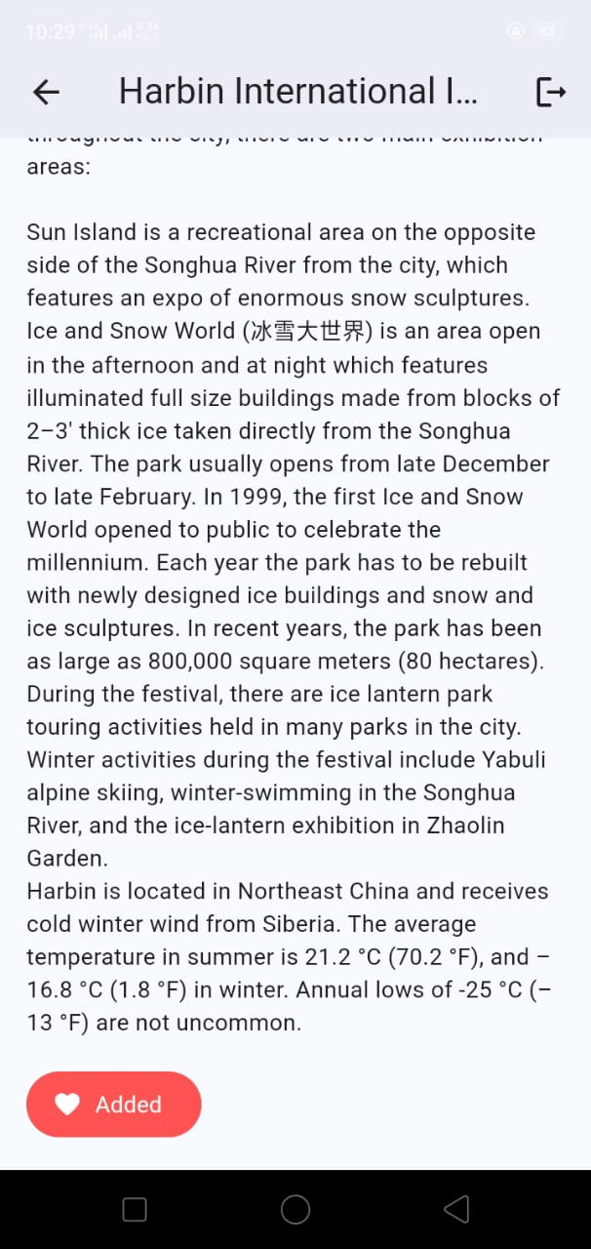

Now Going to my Favorites Screen (to see all my favorite places)

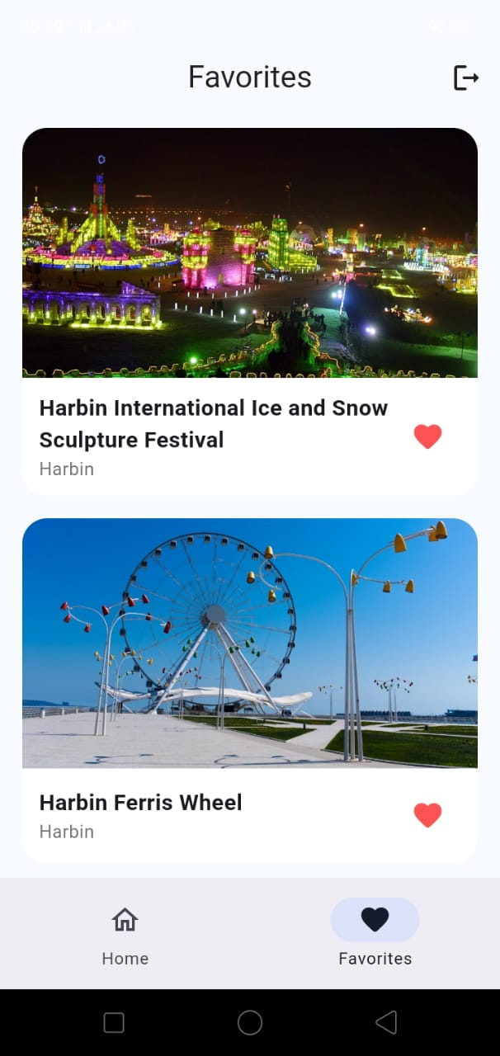

Now see on the Desktop/Tablet Screen

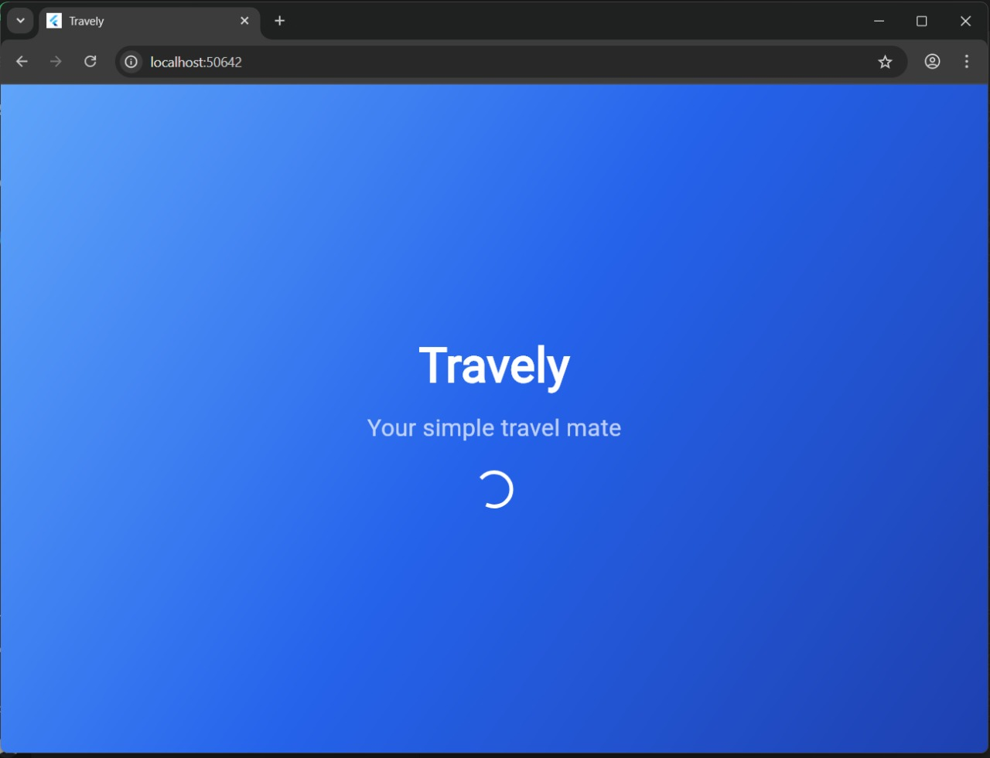

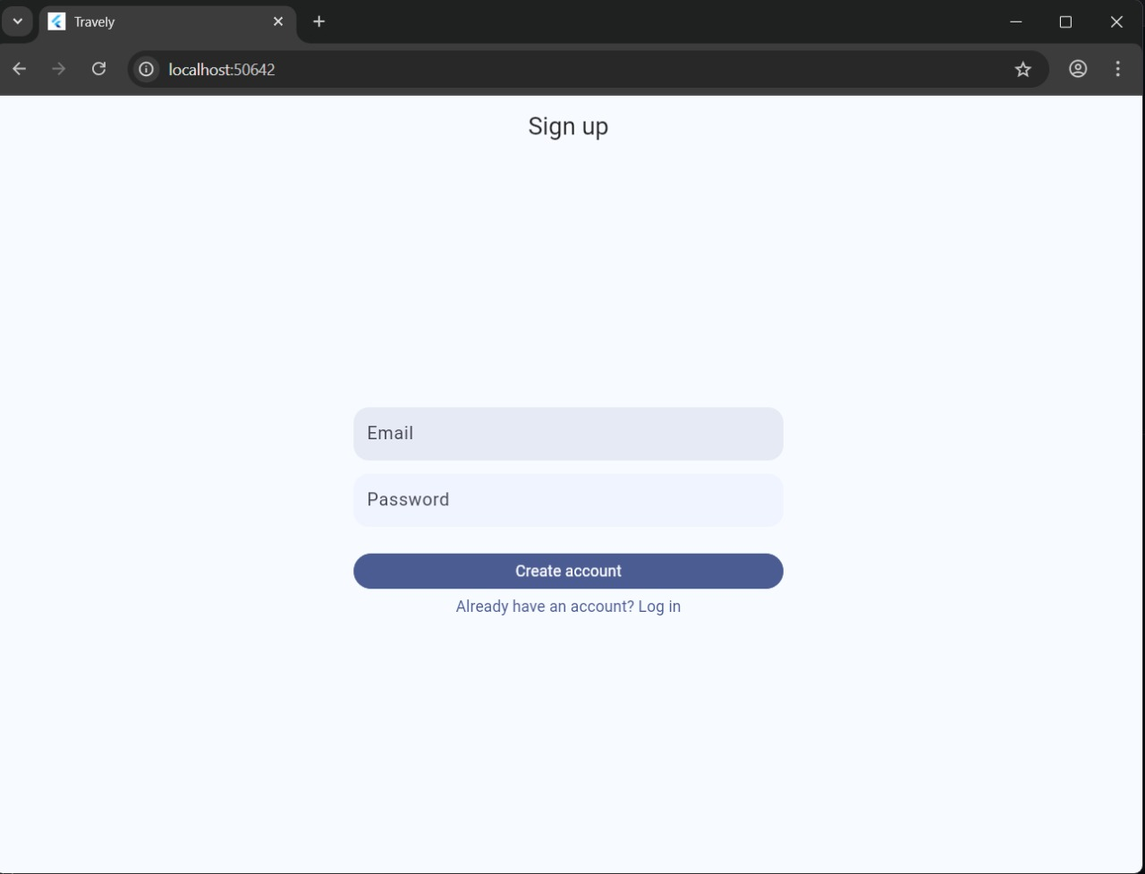

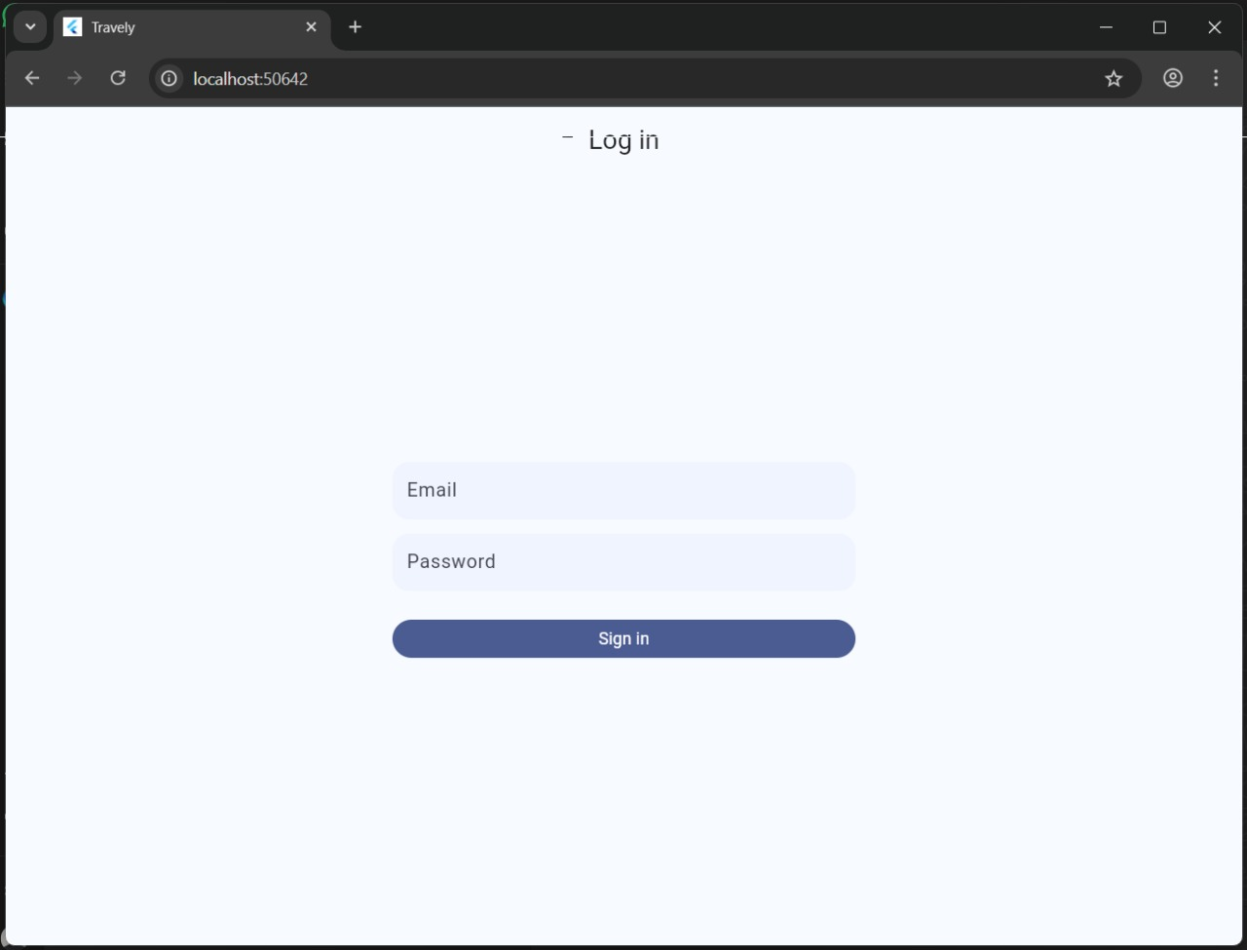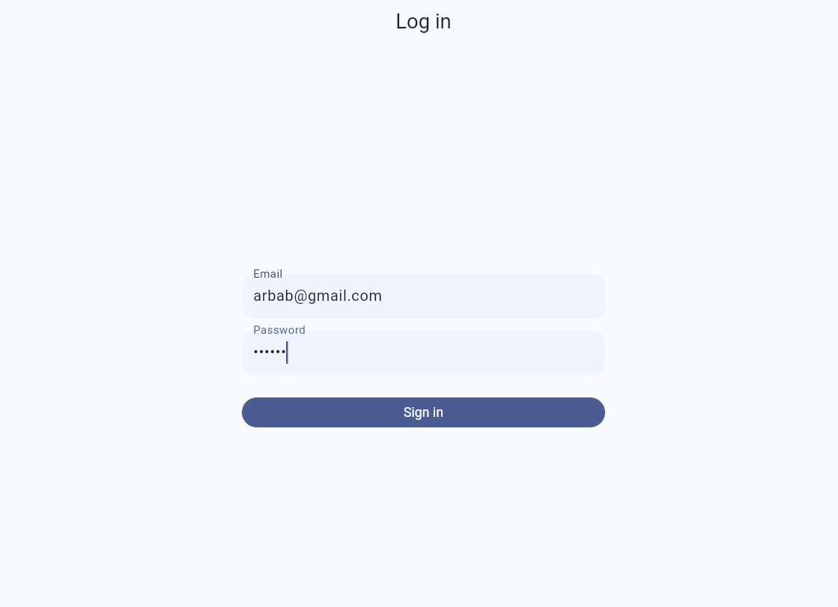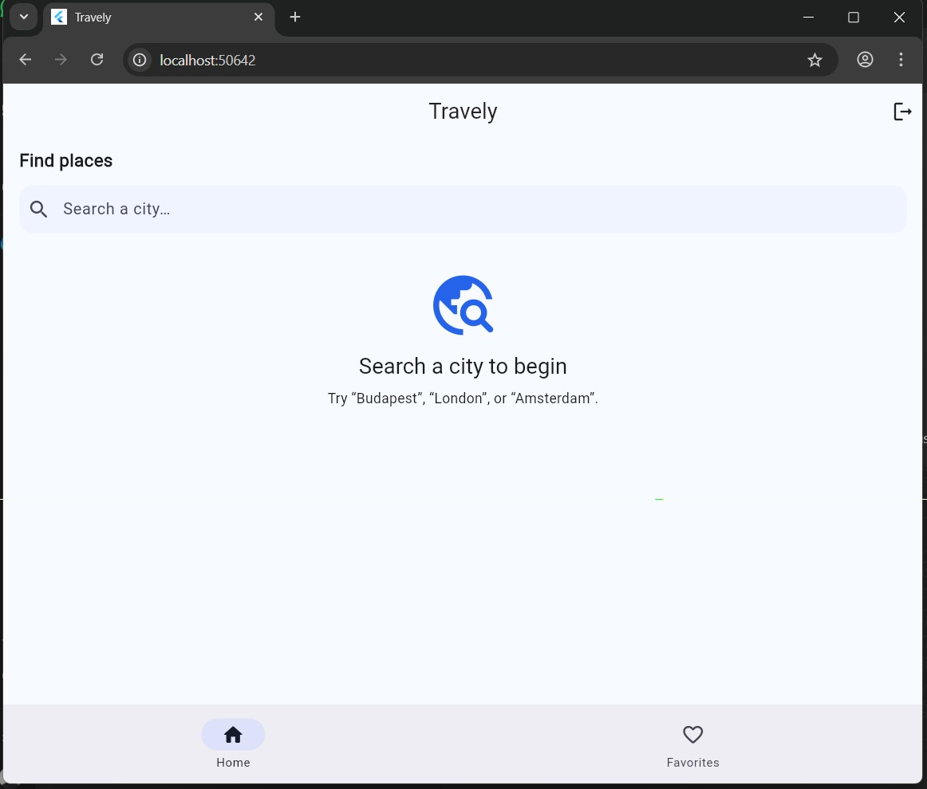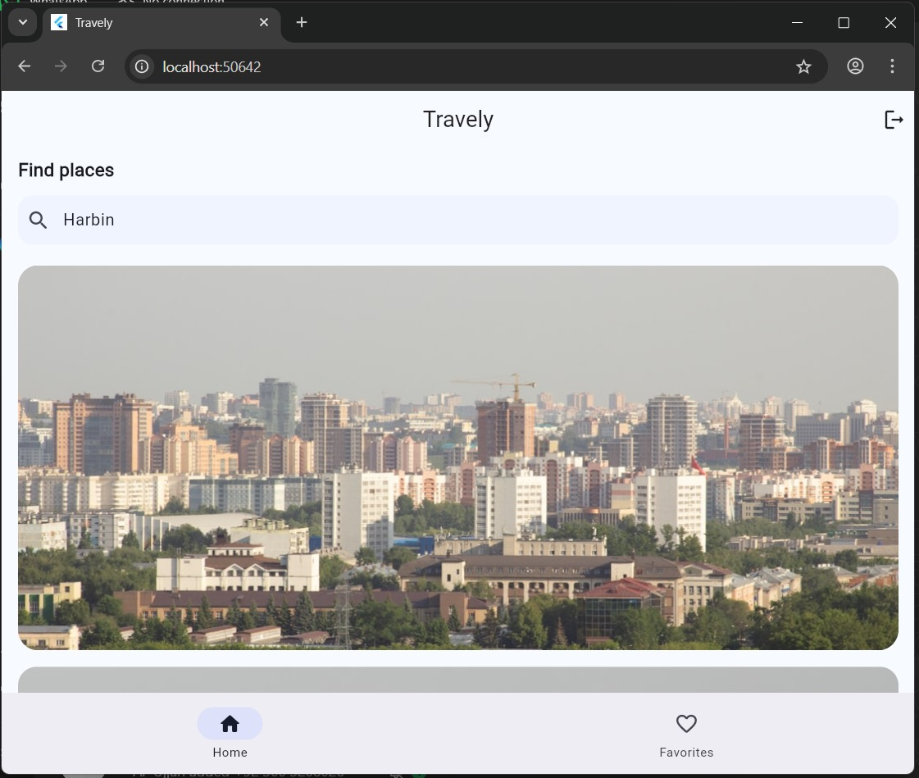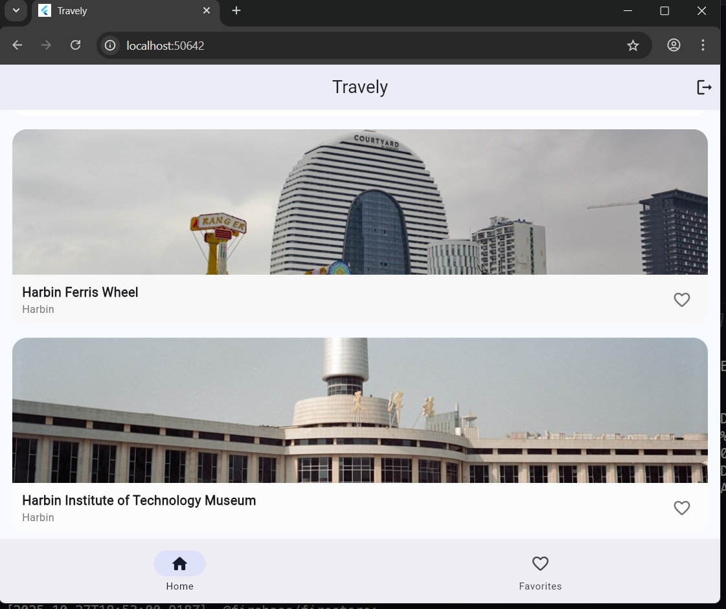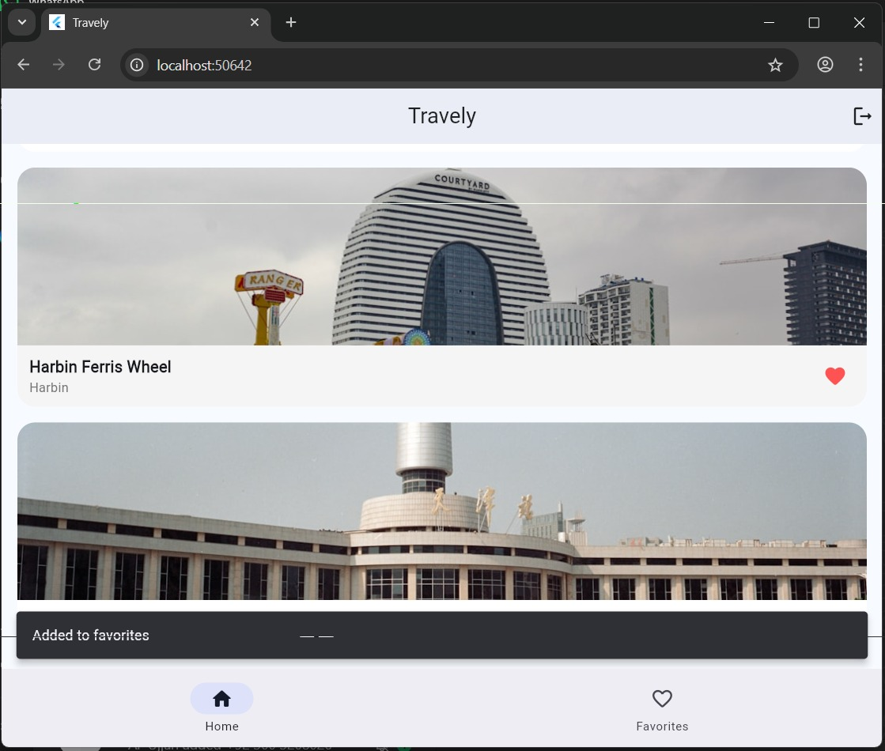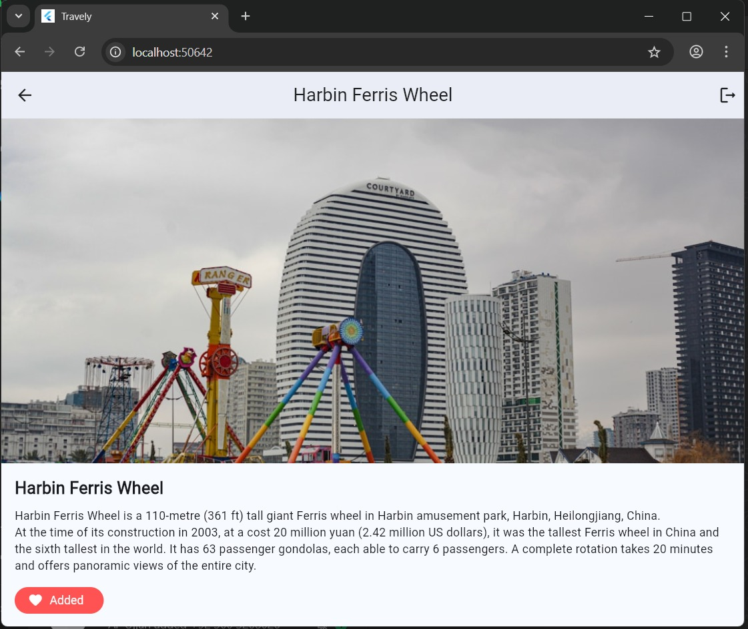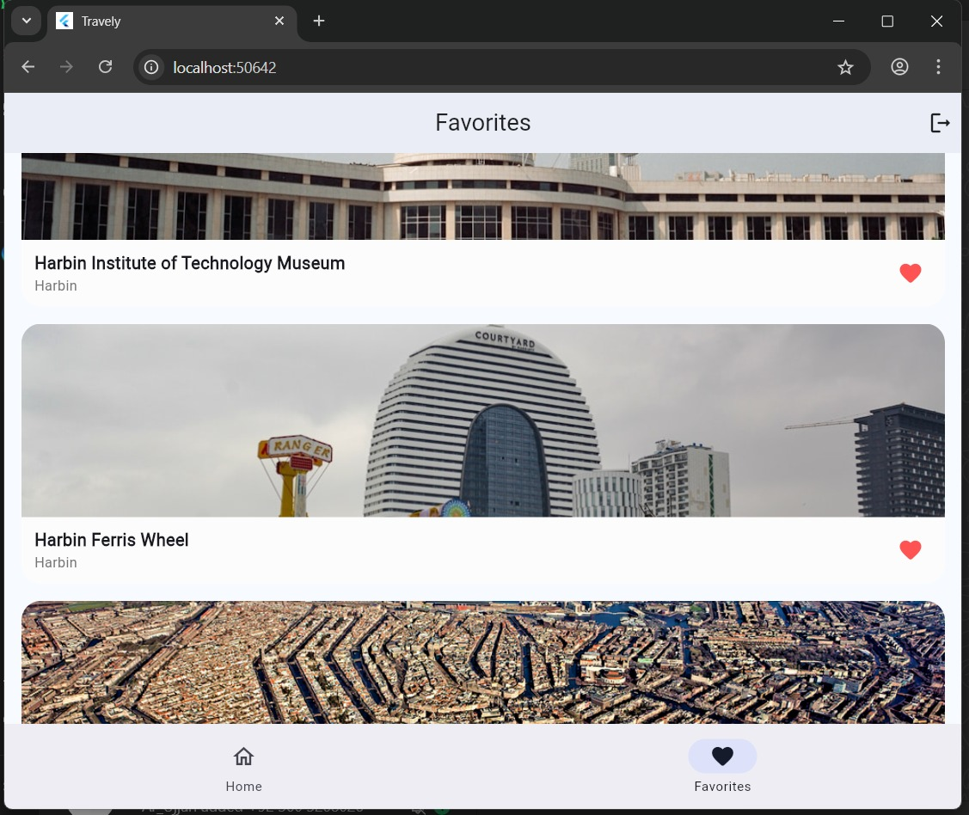

Responsiveness Highlights
- Adaptive layouts using Flexible, Expanded, and MediaQuery.
- Dynamic scaling for phones and tablets.
- Consistent typography and iconography throughout.

4. Data Storage (with Justification)
Travely stores user data in Firebase Firestore, chosen for its:
- Real-time updates: Instantly syncs favorites across devices.
- Cloud scalability: Supports growth without server management.
- Ease of integration: Works natively with Flutter via cloud_firestore.
- Secure access: Protected by Firebase Authentication & Firestore Rules.
Additionally, user authentication (email/password) ensures that each user’s favorites remain private and persist across sessions.

5. APIs / Packages / Plug-ins Used
These dependencies were selected to optimize maintainability, performance, and scalability while keeping the codebase lightweight and modular.

Name | Purpose | Justification
http | For REST API calls to Wikipedia & Unsplash | Lightweight and reliable networking
provider | State management | Clean, reactive architecture
firebase_auth | User authentication | Secure, scalable login/signup
cloud_firestore | Cloud database | Real-time sync for favorites
cached_network_image | Efficient image loading | Smooth scrolling and caching
flutter_dotenv | API key management | Keeps credentials safe
url_launcher | To open external Wikipedia links | Adds convenience

6. Issues and Bugs Encountered & Resolved

Issue | Description | Resolution
Geocode 403 Error | Nominatim requests blocked due to missing headers | Added User-Agent header and optimized query parameters
Firestore Permission Denied | Unpublished database rules caused write failures | Published Firestore rules and re-tested document writes
Favorites Not Updating | Heart icon didn’t reflect real-time updates | Implemented stream-based listener via Firestore
Duplicate Image Fetches | Wikipedia sometimes lacked thumbnails | Added Unsplash fallback with city-based query
Navigation Bug | Splash page skipped bottom navigation | Routed authenticated users to HomeShell() instead of HomePage()

Each issue was debugged using Flutter’s console output and fixed with best practices to ensure stable performance and maintainability.

7. Maintainability and Code Quality
- The app follows Flutter’s Clean Architecture principles with separate layers for UI, logic, and data.
- Code is modular, readable, and versioned on GitHub.
- Consistent naming conventions and comments improve maintainability.
- Provider ensures clean separation of concerns between UI and business logic.

--> Github Repository:

https://github.com/arbabhussainq/Travely

